Issue 1  First issued May2011  Reissued June 2011 | The  DAGGABLAD  Published by  IQELA LENTSANGO:  Dagga Party  of South Africa  Please share this paper with others. | 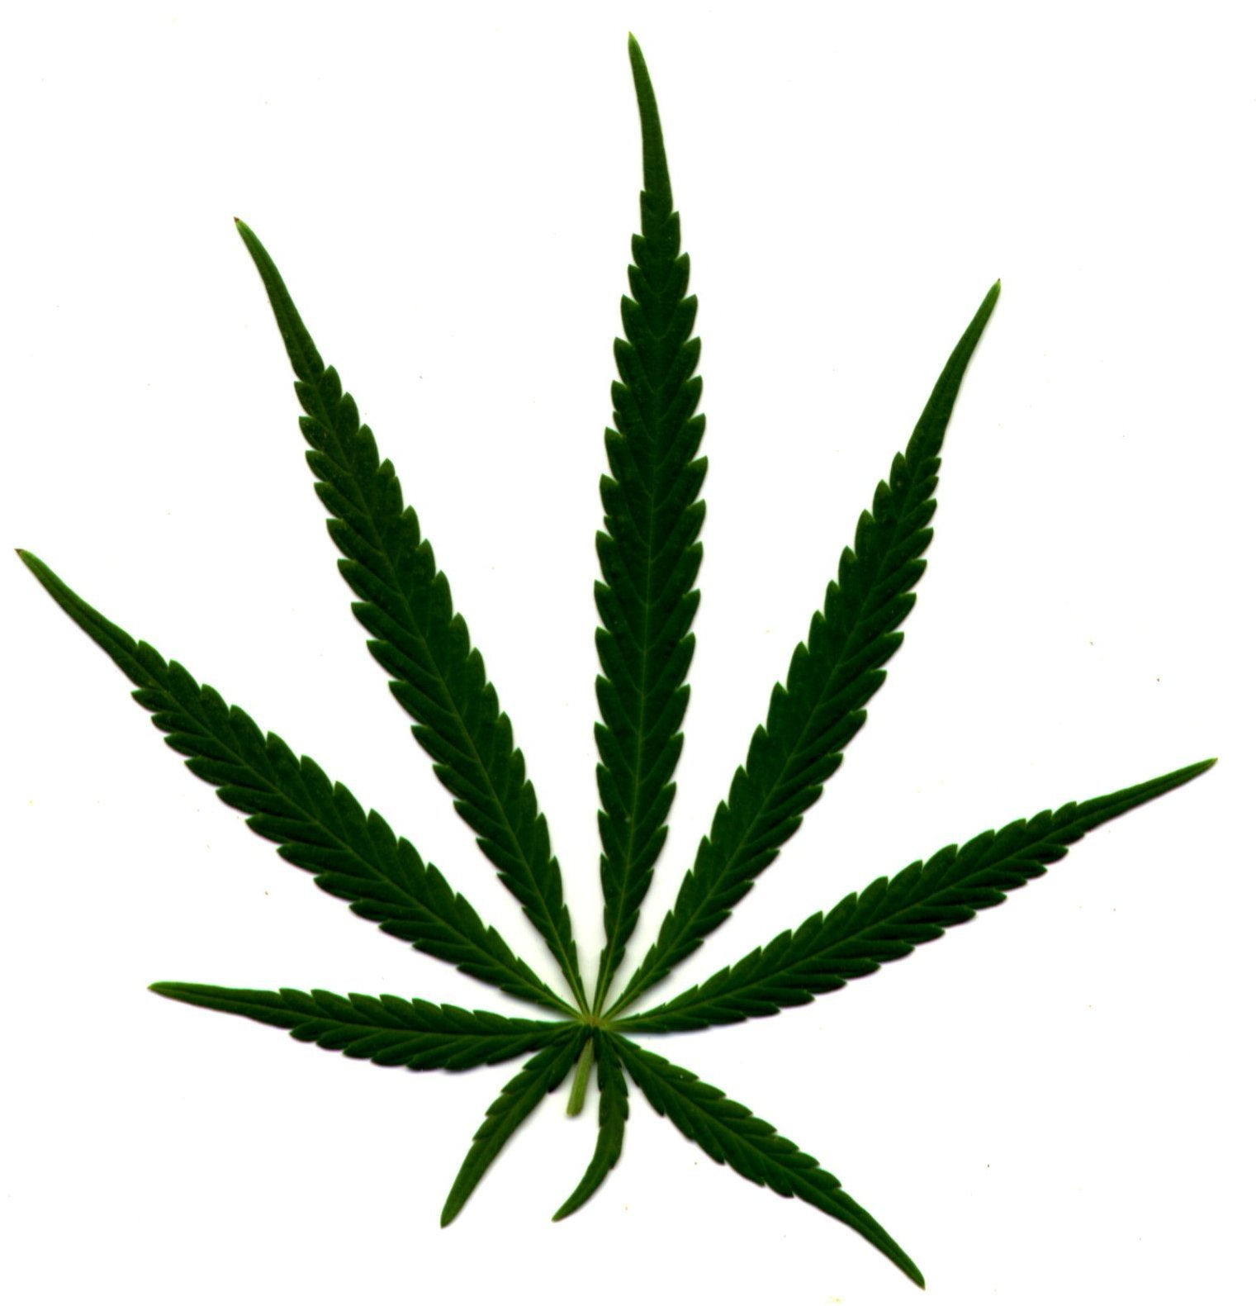  DAGGA IS  FOOD, FUEL,  OIL, TEXTILES,  TOURISM,  BUILDING MATERIALS,  MEDICINE, CULTURE,  SUSTAINABILITY,  EMPLOYMENT

Support the DAGGA PARTY and achieve sustainable economic freedom for your family!

The Dagga Party has been established to allow those voters who might support the legalization of dagga an opportunity to put aside political and cultural differences and to stand together at the ballot. Everyone in South Africa who plants, uses and respects the Dagga Tree (Cannabis sativa) are members of a multiracial cultural minority, the Dagga Culture of South Africa. We ask you all to stand together for justice, by:

- registering to vote, and
- becoming a member of the Dagga Party,
- voting for the Dagga Party of South Africa in elections.

Why Dagga must be legalized in South Africa

Before the arrival of the Dutch and British Empires, dagga was one of the many traditional smokes used by Africans. It was also a source of fibers and the seeds were a valuable source of human nutrition. Dagga was first outlawed in South Africa in 1911 to control Indian workers in KwaZulu-Natal (Dagga is a traditional herb in the Hindu faith) and also in 1925 to control and oppress the members of the newly formed National Union of Mineworkers (NUM). By making Dagga illegal the oppressive racist State disrupted the economic wellbeing and culture of indigenous people.

Dagga was also made illegal to prevent ‘Whites’ (who had alcohol but not dagga) from mixing with ‘non-Whites’ who had dagga but where not permitted to brew or trade in alcohol.

Along with other Apartheid laws such as the Group Areas Act, the criminalisation of dagga provided opportunities for the authorities to harass and arrest the indigenous peoples of South Africa. This pattern of oppression continues today. (E.g.: Stop-and-Search without a search warrant).

If one views the SAP dagga prosecution statistics (saps.org.za) it is clear that dagga use is a very common practice and should be regarded as a legitimate historical cultural practice among SA citizens which should be respected by narcotics laws and by the Bill of Rights of our Constitution.

Dagga law enforcement costs South Africa millions of Rands to imprison otherwise law-abiding and economically active people. The legalization of dagga would allow the SAP to have their workload lightened, allowing them to deal with real crimes that have real victims, such as theft, murder, assault and fraud.

South Africa is missing out on the use of a renewable resource that is easy to cultivate even in poor soils with minimal water. Dagga would easily provide for economic empowerment at grassroots level, by the value adding of Dagga fibers in the manufacture of the many products that can be made. (Paper, cardboard, laminated products, textiles, construction materials, furniture etc)

If we legalized Dagga, we would also be able to obtain our economy literally from out of the atmosphere by capturing the Carbon dioxide with Dagga, instead of continuing to take our economy out of the ground in the form of coal, oil, and gas, all of which damage our atmosphere. The growing of dagga on a mega-scale would not only replace fossil fuels, but also earn Carbon Credits on the global carbon market.

The legalization of Dagga would empower the poorest citizens to actively participate in the new dagga-based economy, and would also give a huge boost to the viability of agricultural land reform projects. We could also create a dagga tourism industry and a global market for our superior dagga fibre-based products, our carbon-neutral fuel, and medicines, .

It is time for our culture, the Dagga Culture of South Africa, to stand together for justice and a sustainable future through the legalization of Dagga for the benefit of all the citizens of our country.

Legalize Dagga!
Vote IQELA LENTSANGO: Dagga Party of South Africa!!!

Share the Vision!
With Dagga legalized and a sustainable dagga-based economy in South Africa, no citizen would find it necessary to commit crime, or suffer from hunger, or be without clothing, housing or cash. Everyone would be able to enjoy fulfilling work opportunities, and we would all enjoy a deeper level of choice and freedom in our democratic and tolerant nation.

We would all be healthier citizens, the police would suffer less work stress, agriculture will be more sustainable, there will better housing, industry would pollute less, and our tourism industry would be greatly strengthened. We would achieve a carbon-neutral economy, and be able to reduce, or even avert, the disaster of global warming and climate change.

Majority governance by the elected Dagga Party will achieve:

Immediate Revision of the laws against Dagga

The possession and cultivation of dagga and its seed by individual citizens will be legal subject to their respect for the rights of others.

All citizens will be encouraged to participate in the cultivation of Dagga.(Large scale corporate growers shall not be permitted until communities have been empowered to benefit from the production and value adding of Cannabis raw materials, and legislation is in place to maximise the benefits of a Cannabis economy for the presently disadvantaged.)

The DAGGA PARTY shall strive for creation of a carbon-neutral, people-centered, dagga-based economy whose success or failure will be measured by Human and Environmental development indices (literacy, infant health, TB rates, biodiversity etc) at a local level, rather than by gross measures of consumption of resources (GDP) or the trading of shares (JSE index).

We stand for the granting of a pardon to all citizens previously convicted for dagga possession or cultivation, and the wiping of dagga convictions from their criminal record.

Prisoners shall also have the right to use dagga and to grow their own for personal use, and also to help cover the costs of their maintenance.

Renewable Energy Technologies not Nuclear Power

RDP housing subsidies will be raised to include Dagga-fibre ceilings and insulation, Solar Water Heaters, a minimum of four rooms, and energy efficient stoves for wood and gas. Housing will be constructed with durable Dagga-based building materials and will feature guttering and raintanks.

Zero-interest loan facilities will be made available for homeowners to install Solar Water Heaters, with rates rebates for those who do so.

The State will invest in large scale Solar and Wind Power projects, medium scale biogas systems, and housing designed to supply all the energy needs of the occupants, with an exportable surplus that will be able to be sold to the ESKOM power network.

ESKOM will be transformed from being a monopolistic power supplier using coal and nuclear power into the distributor of renewable energy generated by every house and township and factory in South Africa.

The Koeberg Nuclear Reactor will be decommissioned as soon as alternative renewable energy sources are established.

State assistance will be given to farmers to establish small water catchment dams, biogas installations, earthworks for the prevention of erosion and salt drainage in irrigation lands and salted ground.

Increased Social Development to reduce crime
The Dagga Party will organize more social workers and development programs at community level to prevent crimes that arise from poverty.

Members of the Dagga Party shall strive to work together on development in their communities.

Leadership in International Relations
With a Dagga Party majority in Councils and in Parliament, active and constructive assistance will be provided for other African and developing nations in infrastructure development, conflict resolution, agricultural and technological assistance, medical health systems, land care, and cooperation towards the establishment of a connected network of national biodiversity conservation parks.

South Africa will also lead by example in the reduction of emissions of carbon dioxide and other greenhouse gases, and shall assist developing countries towards similar goals. Where necessary, South Africa shall agitate internationally against nations who fail to curb their carbon emissions.

Other important policies
The Dagga Party also proposes:

- The taxation of the extraction of non-renewable resources (e.g. metals,) and stringent prosecution of polluters.

- The closing of mines and activities that threaten to damage agricultural land, rivers and ground water.

- A 2 year non-military National Service for all matriculating school leavers which will include training in First Aid, Life skills, land care, housing construction, and international assistance programs, in exchange for rights, upon completion of the National Service, to a portion of land that will be developed according to a specific environmentally sustainable pattern. The national service will be able to be regarded as a basic tertiary education with qualifications awarded for achievements.

- A Basic Income Grant (BIG) shall be provided for all citizens, which will be funded in part by taxation on the turnover of JSE shares. (A Tobin-Henderson tax)

- An additional subsidy shall be granted to all female teenagers over 16 years who remain in school and do not fall pregnant, with a bonus payable upon matriculation.

- The Dagga Party will promote sustainable low impact agricultural practices and policies with an emphasis on respect for all farmers and farm workers, reforestation, aquaculture, Permaculture, and the conservation of natural ecosystems.

For more detailed information on the policies of the Dagga Party, visit www.daggaparty.co.za .

Become a Member of the Dagga Party.

If you are community conscious, non-violent person who supports the legalization of Dagga and other policies of the Dagga Party, you are invited to become a member of your Ward Group, or to help in establishing a group in the Ward.

To learn more about forming a Constituent Association (ward group) visit www.daggaparty.co.za/forming a constituent association.

Good Reasons to Vote for Dagga:

- Dagga seeds are not narcotic and when ground as flour provide up to 24% protein, and all the amino acids necessary for human nutrition.

- Dagga seeds contain Omega 3, 6 and 9 fatty acids in a perfect balance for human cardiac and mental health.

- Dagga seed oil, which is non-narcotic and identical to hemp oil, can be used in cooking, for energy, as a health supplement, as an industrial lubricant and, if necessary, as a fuel.

- Dagga fibres can be used for the manufacture of textiles, livestock bedding, construction materials, paper, packaging and many other products.

- The inside of dagga sticks (the hurds) can (after the removal of the outer fibres) be used for the manufacture of biodegradable plastics, or carbon-neutral liquid fuel suitable for motor vehicles.

- Dagga is not physically addictive like tobacco, alcohol, or many over-the-counter drugs.

- Dagga is safer to use than tobacco and alcohol, which together cause 100 times more deaths than the total combined deaths resulting from all other illegal drugs.

- Dagga used in a mix with tobacco mitigates the cancer and heart disease impacts of tobacco. Dagga should preferably NOT be mixed with other substances.

- Dagga, used moderately, in conjunction with harm minimisation techniques, does not adversely affect motor coordination, driving skills, cognitive skills, workplace safety, lung function, quality of work, or motivation in experienced smokers.

- The estimated LTD50% (lethal toxic dose for 50% of subjects) for dagga is 750kg to be consumed within fifteen minutes, a physical impossibility. (Dagga is safer than sugar!)

- No deaths have ever been caused by the use or abuse of dagga in over 10 000 years of human use.

- The narcotic ingredient in dagga, THC (delta 9-Tetrahydrocannibinol), is useful for the treatment of pain, nausea, asthma, colds and flu, menstrual cramps, alcoholism, Crohn’s disease, spastic colon, muscular spasm in Multiple Sclerosis, epilepsy, glaucoma of the eye, AIDS-related wasting, motor neurone disease, mental irritability, depression, and it is supportive in radiation and chemotherapy against cancer.

- Recent research indicates that Dagga can be used to cure cancer, particularly brain- and skin cancer.

- One dagga joint boosts melatonin levels in our body by up to 4000% 2 hours after smoking a joint. Melatonin is a natural brain hormone which is a very effective anti-oxidant that captures free radical molecules in our cells and prevents damage to our DNA. A decline of melatonin in our body is linked to the aging process. Dagga use thus assists health and slows the aging process.

Despite SAP and SA Medical Council propaganda against it, Dagga has great potential to be a useful and positive plant for South African society. So please consider voting for a sustainable future by making your mark for the Dagga Party !

A Vision for Sustainable Municipalities

The Dagga Party has a specific plan to make all the villages in a Municipality more sustainable. At the moment the treated water at the sewage treatment systems of each village is discharged into local rivers, and is lost from the local economy. We propose that this water MUST be used for agricultural irrigation for the benefit of the local communities. We also propose that aquaculture projects be initiated in the water treatment dams below the sewage treatment works of each village.

We also want to convert all sewerage works into biogas systems for the production of methane gas to generate electrical power locally. If all sewage and garden and crop wastes in an area are anaerobically fermented in a biogas system, approximately five to eight times more power will be produced than is presently consumed in that area. Biogas installations typically have a payback period on investment of two years, if calculated against the present cost of ESKOM electricity.

In order to use the extra power that is generated it will be possible to develop a light industrial area nearby, or the extra power could be sold to ESKOM. This strategy would replace a Municipality’s present fossil-carbon emissions (that are emitted by ESKOM) with a locally produced, carbon-neutral energy resource. The necessary modifications to the existing sewage treatment systems will create real work that will ensure the economic independence of the area in the future.

The success of any area also depends on the maximum quantity of water than can be captured and stored, intelligently used, and recycled if possible. Councilors from the Dagga Party will make every attempt to create a project to install gutters and rain tanks on all houses and buildings, and to promote an integrated water catchment management system for each village.

Control over essential resources and local opportunities for work should be kept for local citizens, and should not be granted to outside companies by means of tender processes.

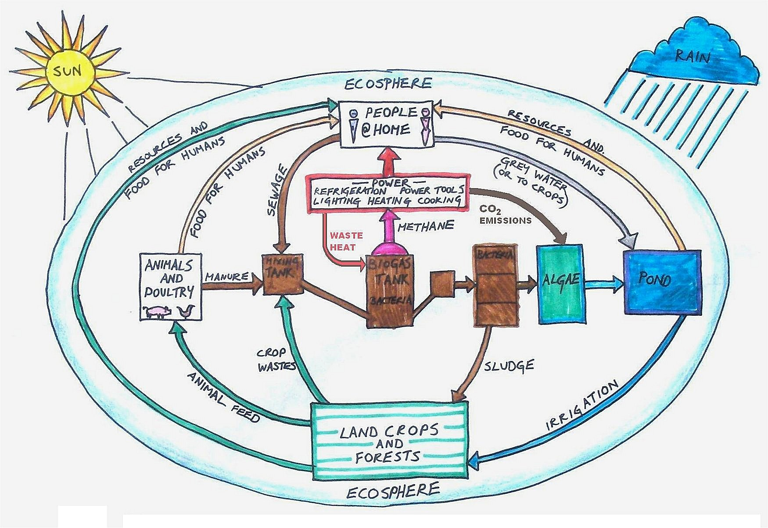
The diagram above shows the ecological connections and balances that our proposals would achieve in each village. Elements in the landscape that are presently lacking would receive investment and be located so that the necessary linkages between these elements, as indicated in the diagram, are achieved.

Another essential project is the expansion of agriculture (including the creation of school and family vegetable gardens!) to effectively replace the importation of food requirements into a Municipality with the local production of a great diversity of agricultural products and food supply. An abundant agriculture is an essential foundation for the development of a successful culture.

The more that any area can be independent of imported resources (electricity, food, water, skills etc) the more successful the local businesses will be. The proposed changes to the system and the abovementioned projects will ensure this independence of communities, and we ask ALL voters in the Municipality (Dagga-users and non-users together!) to support this vision for sustainability with your votes.

And then there is also the Dagga…☺

PLEASE VOTE

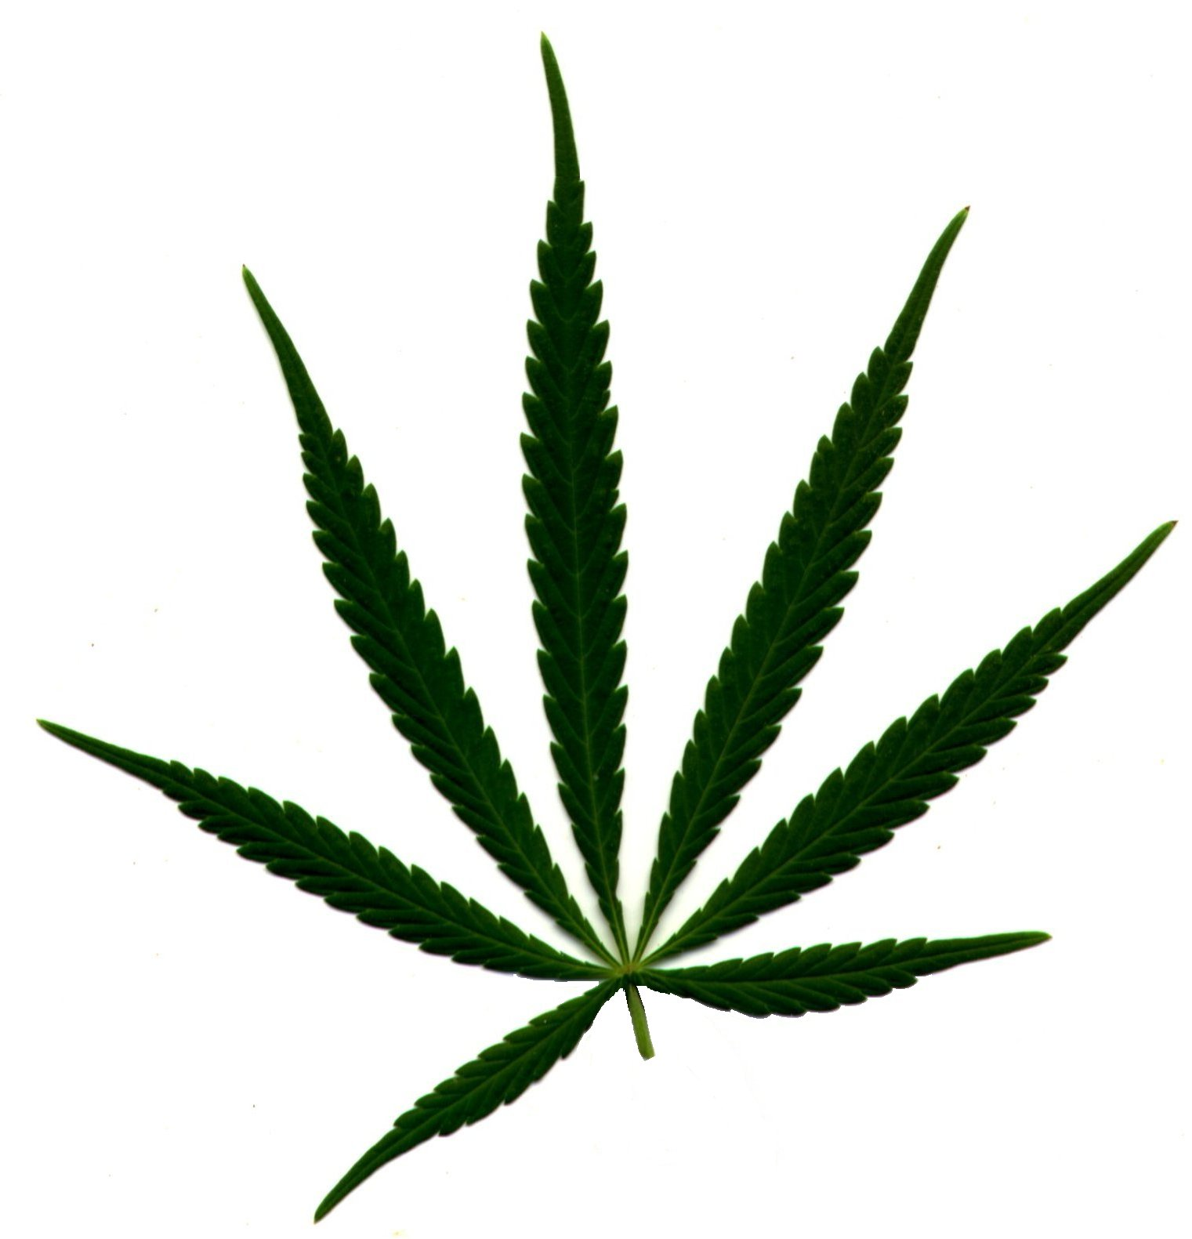 |  | 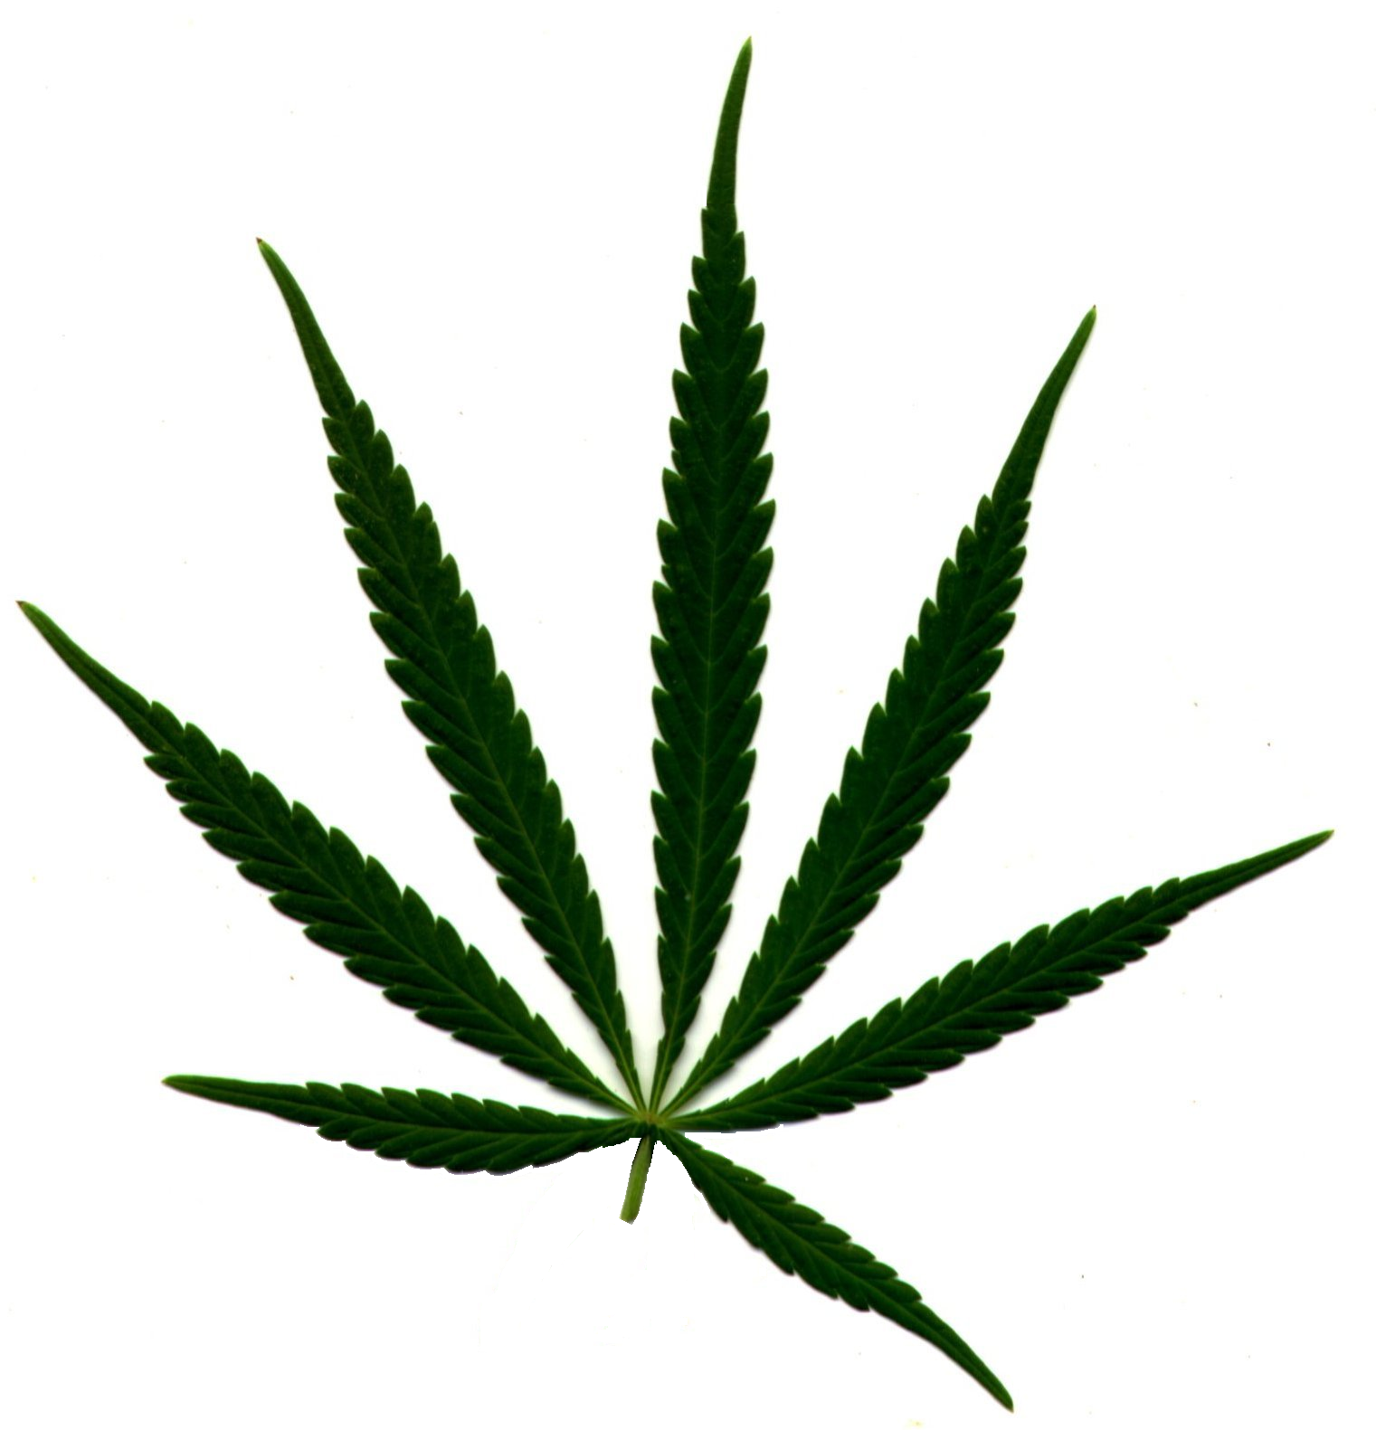

In all elections.

www.daggaparty.co.za

